Team Name: Fuse.AI Team

Q. Which vegetable has a maximum and minimum price in the last 3 days?

A. Vegetable with Maximum Price:

* पार्सले
* सेलरी

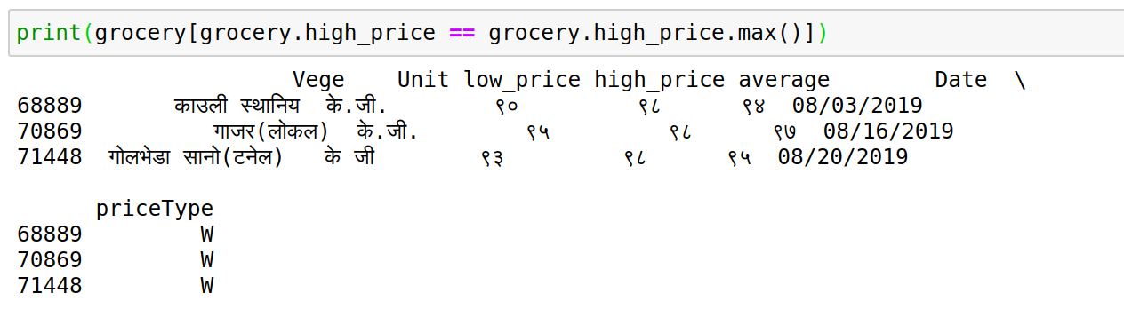

Vegetable with Maximum Price:

* फर्सी हरियो(लाम्चो)

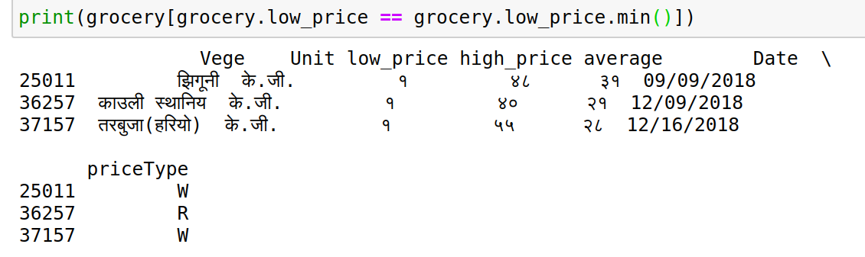

Vegetable with constant price :

Vegetable with increase price

vegetable with decrease price